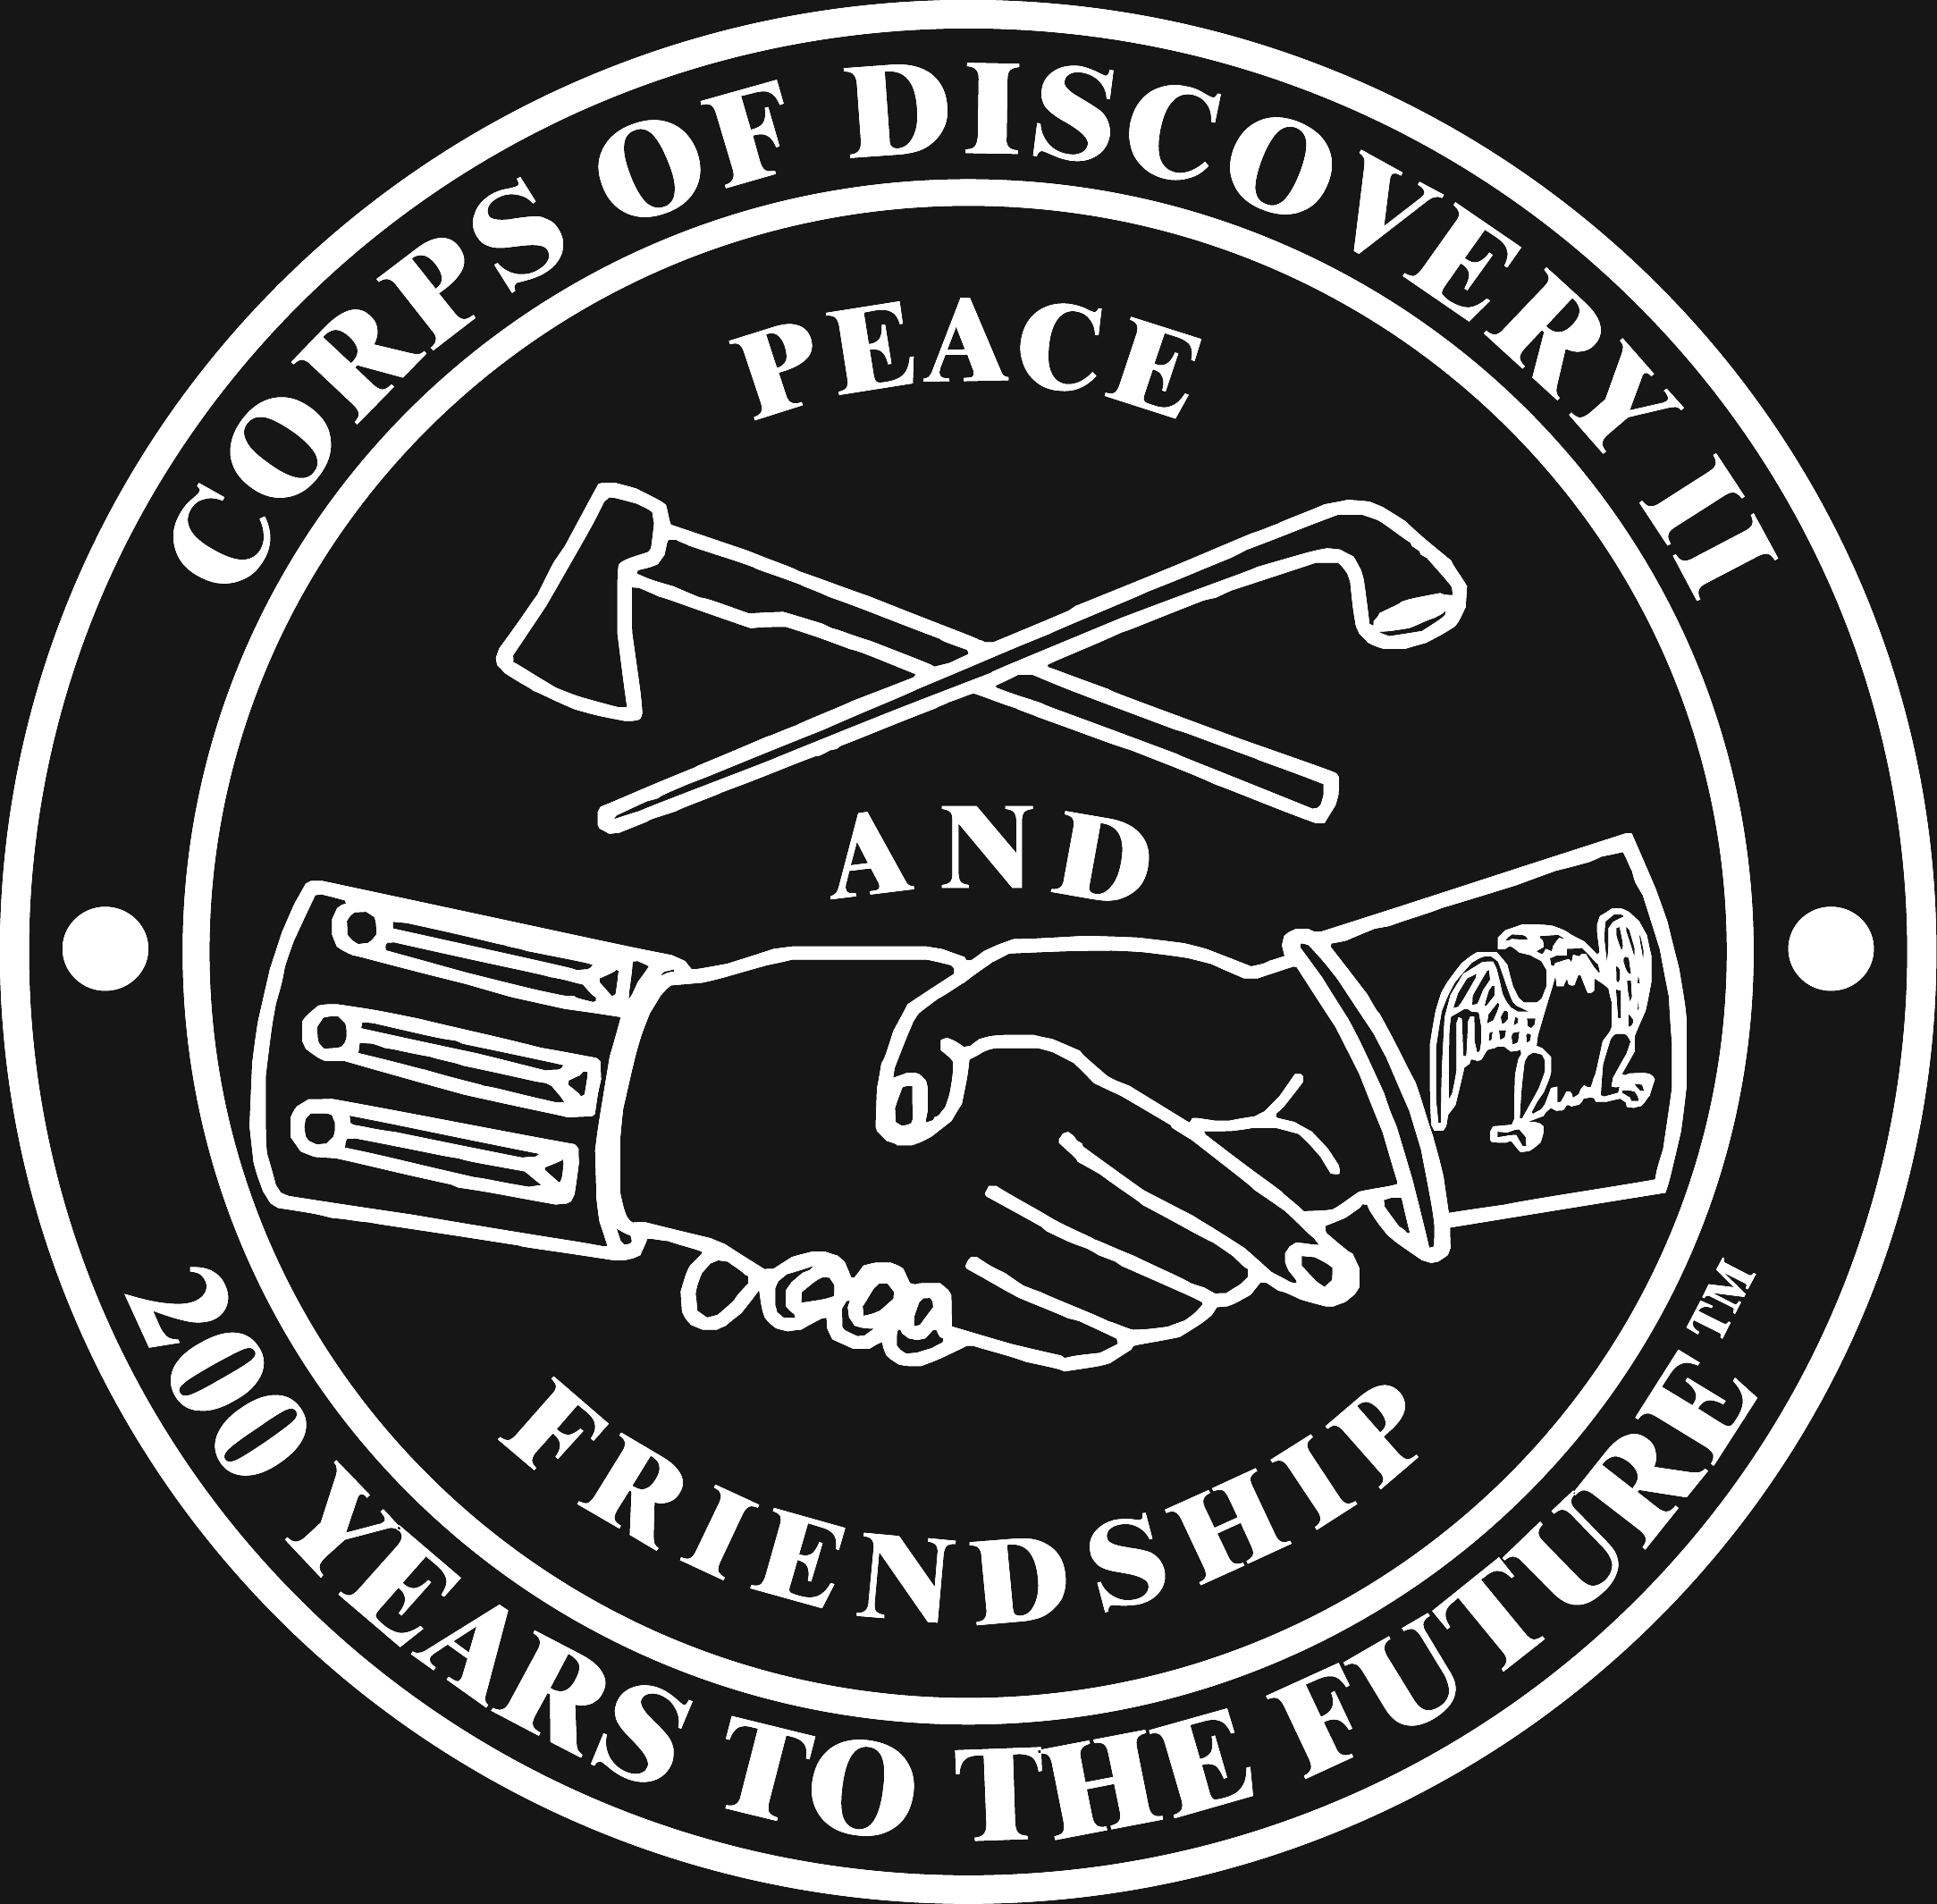
Corps of Discovery II
Lewis and Clark Traveling Exhibit

Panel 1

“We will find the shortest and most convenient route of communication between the United States and the Pacific Ocean.” With these words, Thomas Jefferson, third President of the United States, conceived of the greatest American adventure of all time.

Americans did not know what lay beyond the Mississippi River. Jefferson believed they would discover a land of volcanoes, llamas, even woolly mammoths, but most importantly he hoped they would discover a northwest passage to Asia.

